**Spring REST using Spring Boot 3**

**OUTPUT:**

**Exercise 1: Create a Spring Web Project using Maven**



**Exercise 2:** **Spring Core – Load Country from Spring Configuration XML** 



**Exercise 3: Hello World RESTful Web Service**

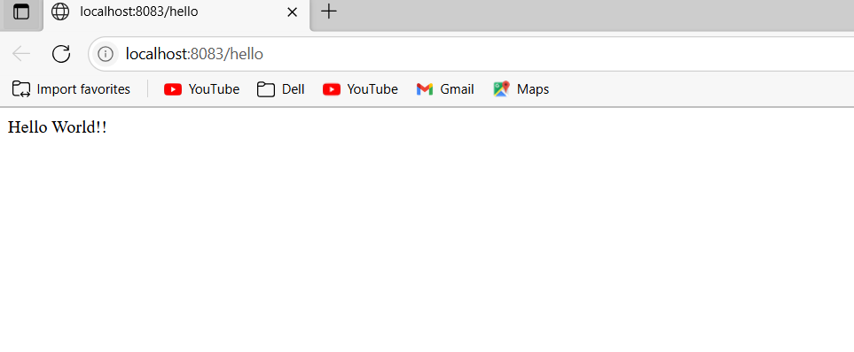

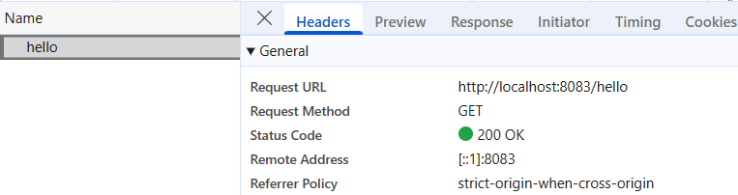

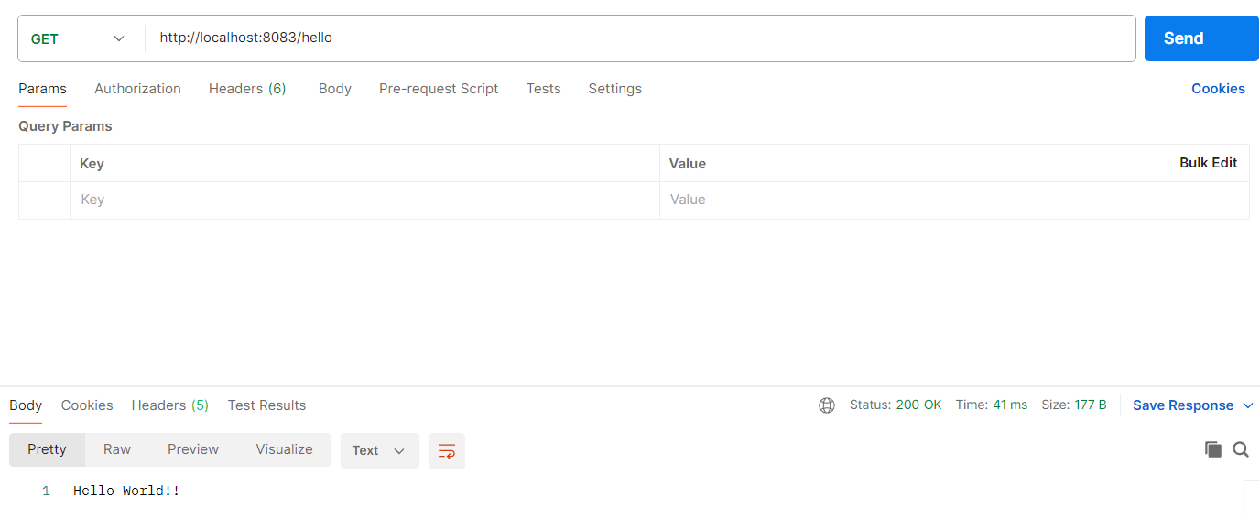

**Exercise 4: REST - Country Web Service**

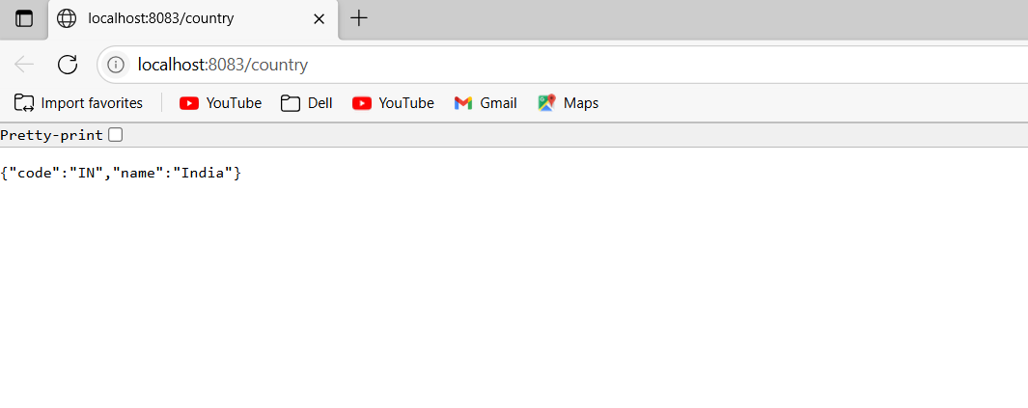

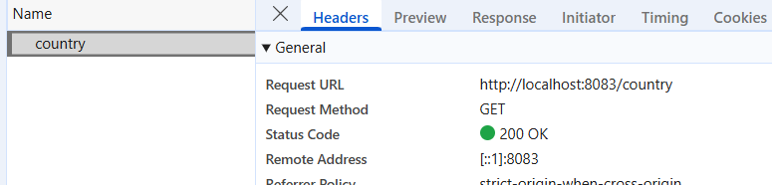

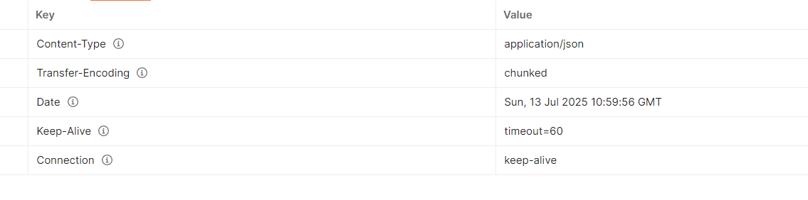

**Exercise 5: REST - Get country based on country code**

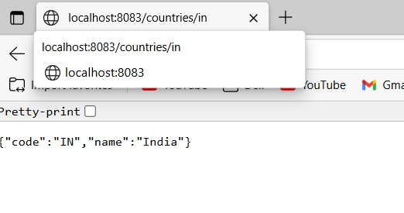

**Exercise 6: Create authentication service that returns JWT**

